**3) Evaluation and Comparison**

**Task**:

Implement and compare two different object detection algorithms (e.g., YOLO and SSD) for small drone detection and tracking using TensorFlow or PyTorch. Train both models on the same dataset and evaluate their performance in terms of detection accuracy, tracking stability, and computational efficiency. Provide a detailed comparison report highlighting the strengths and weaknesses of each approach.

**Model Architecture**:

1. **Yolo Model**: Fine-tuned the yolo V8 large model.
2. **Model from Scratch**: Training the by taking the reference from AarohiSingla/SSD-Tensorflow-On-Custom-Dataset on GitHub.

**Hyper parameters:**

|  |  |  |
| --- | --- | --- |
|  | **Yolo Model** | **SSD Model** |
| 1. Base Model | YoloV8 large | None |
| 1. Target size of Image | (224, 224) | (224, 224) |
| 1. Batch Size | 16 | 16 |
| 1. epochs | 100 | 100 |

**Data Source:**

Data was obtained from web through freely available websites, such as:

1. <https://unsplash.com/>
2. <https://pixelied.com/>
3. <https://www.istockphoto.com/> , etc.

**Data Pre-processing:**

Data was pre-processed by tensorflow’s ImageDataGenerator. Following are the processes performed:

1. Image size: (224, 224)
2. Rescale: 1/255, etc.

**Model Performance:**

Training stopped early as no improvement observed in last 20 epochs. Best results observed at epoch 1, best model saved as best.pt. Here are some of the data in graph format:

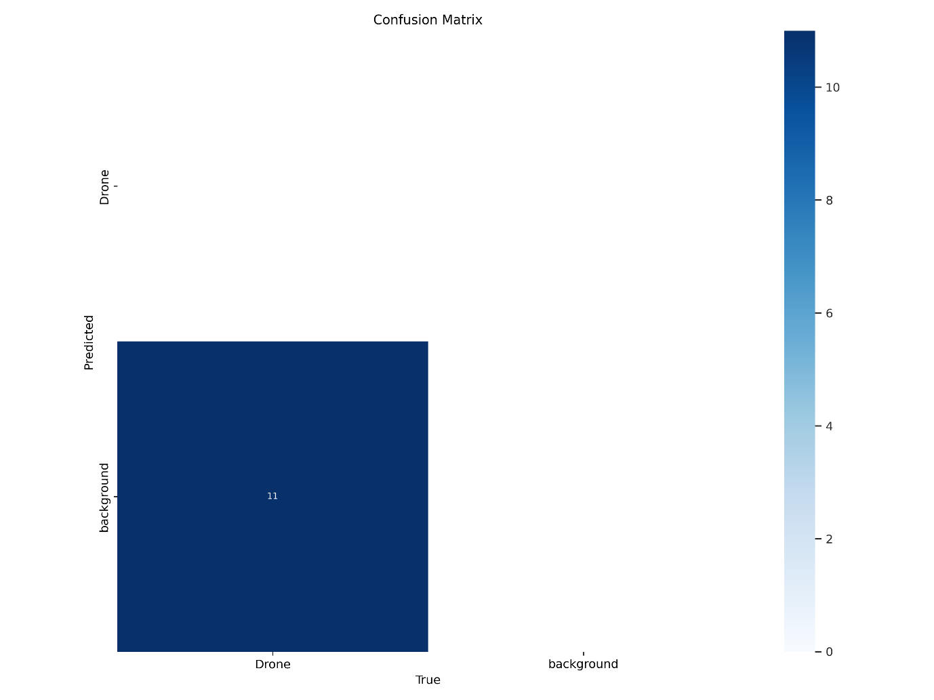

1. This is the confusion matrix showcasing that all the 11 occurrences of drones in images as predicted as background by model.

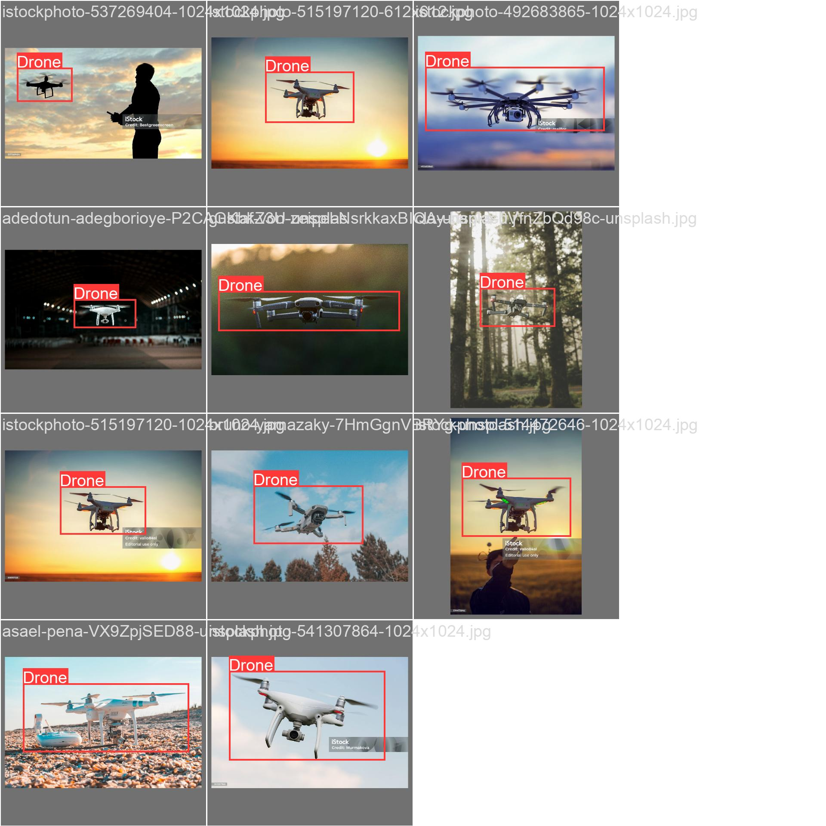

1. This is the images with detections which should have been detected by model.

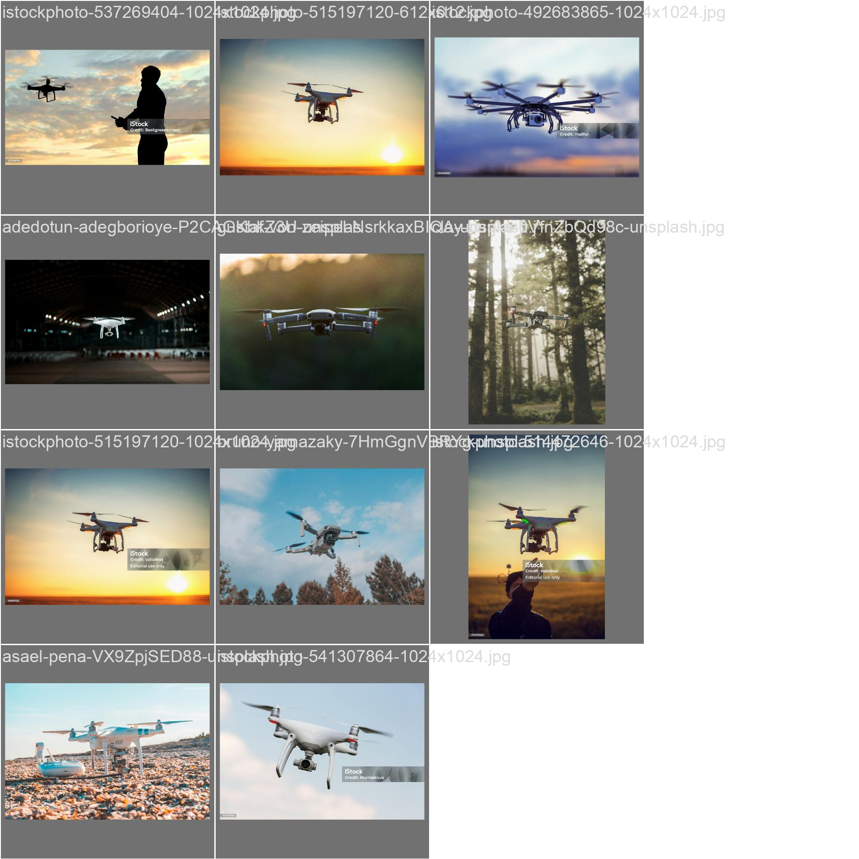

1. Here is the actual predictions by the model, showcasing model unable to learn from the provided data.

**Conclusion/Inference:**

1. Yolo model seems to unable to learn from provided data, signifying the underlying issue with the image data available.
2. To improve the model we could increase the quality and quantity of the image data provided.
3. We can perform the more data pre-processing to increase the likelihood of model understanding data provided and learn from it.

**Author:**

**Akshay Kumar**

**Phone Number: +91 7488269891**

**E-mail Address: akshaysatyam2003@gmail.com**